**SOFT 9021 – Cloud Application Frameworks**

**Assignment 1 Notes – Jimmy Collins / R00145569**

The below outlines the items I have completed for this assignment, as per the specification.

**Part 1 + Part 2**

Setup steps completed to get MySQL installed, the database up and running and the code for the services up and running on my local machine.

Before beginning the code fixes, I also wanted to clean up the user interface a little. I used bootstrap to do this before I begun.

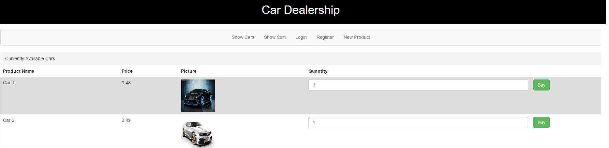

**Part 3**

**(a)**

A new product form is available that allows a user to add new products to the MySQL database.

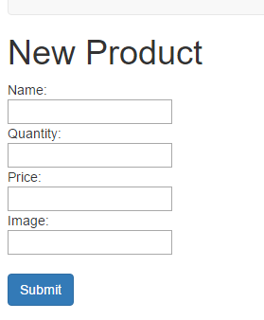

**(b)**

I added the relevant code in the catalogue service to submit the data from the form created in part (a) to the database.

This can be found starting on line 30 in app.js in the **catalogue** service code.

**Part 4**

**(a)**

Now when a user adds the same item twice to the cart, the quantity of the existing item in the cart is added to, rather than adding a new entry in the cart.

The relevant code that does this can be found starting on line 30 in app.js in the **cart** service code.

**(b)**

I’ve added some styling to the total in the cart and also to the checkout button so a user knows exactly how much they are checking out for:

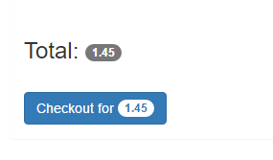

**(c)**

The delete button in the cart is no functional. The relevant code I’ve added can be found starting on line 76 in app.js in the **cart** service code.